
Pak Users Manual

Table of Contents

1. Introduction
1. Operator Functions
a. Startup
b. Logging in

- Administrative Interface
- Development Notes

Introduction:

A few key terms are defined below:

Tare Weight : The weight of packing materials used to pack the mount. Which is the box, staples and any wood used.

Net Weight: The weight of just the packed parts, not including the box.

Gross Weight: The weight of the box and all parts in it.

When weighing a completely packed box the software subtract the tare weight from the gross weight and compares this to a net weight that has been pre measured and stored in the system. If there are large variations this means that either too many items were put in the box (net too high) or something is missing from the box (net too low). This is the primary check for the accuracy of a packed box. A picture is also taken of the contents of the box so that they may be reviewed later and other packing errors may be identified. While these two checks can help identify some packing problems it can't prevent all possible causes of an incorrectly packed box.

DDPak gets production numbers by keeping track of the labels printed during a work day.

Operator Functions:

a. Startup :

Double click the ddPak icon on the desktop. Enter username and password into the login screen and hit 'Ok' or enter.
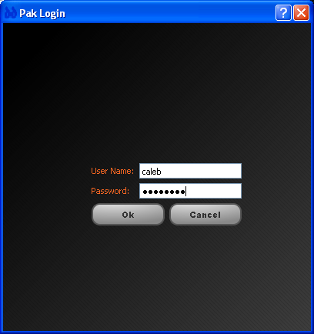

DDpak software is meant to run in conjunction with another piece of software called PSRemote which is responsible for taking the pictures. Start PSRemote by double clicking the PSremote icon on the desktop.

b. Main Screen:

The first thing to do is select a kit to weigh from the kits on carriers view. Click your mouse on the line of the kit you want to pack and then click the 'Select' button.
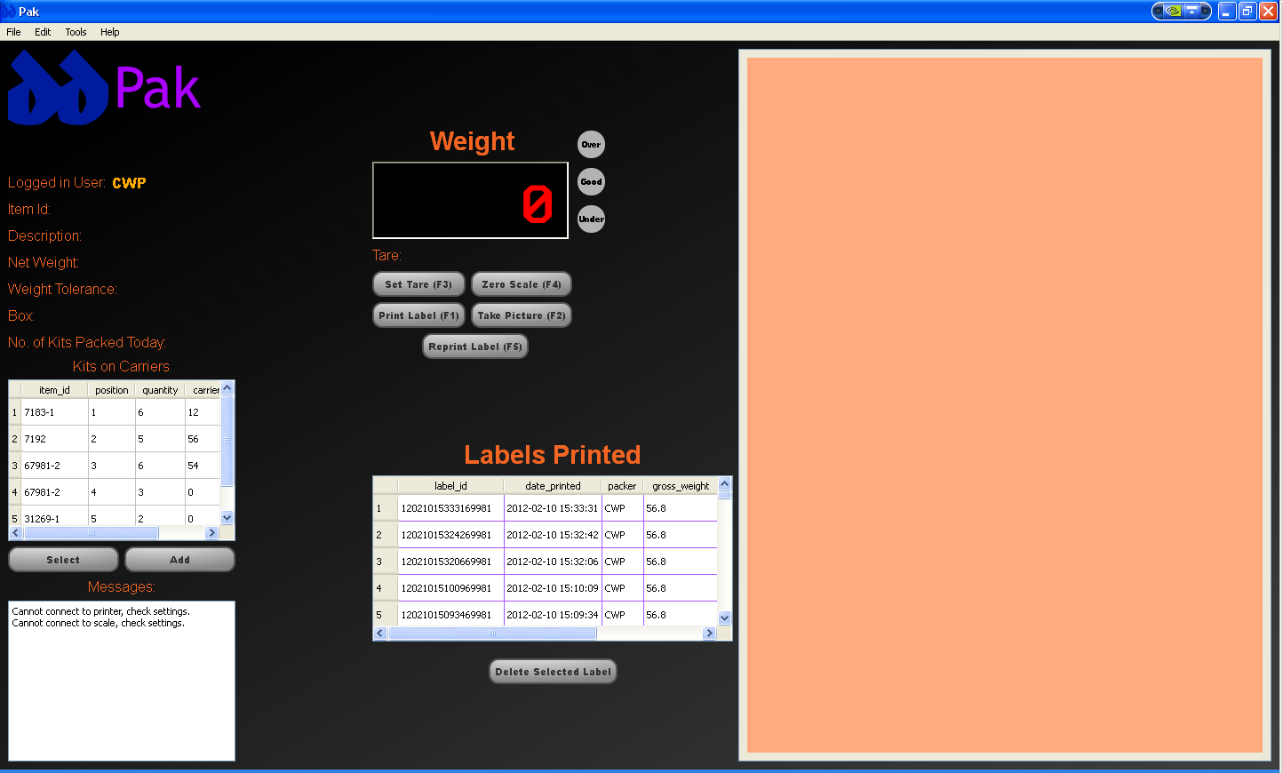

If there are no kits in the list then they can be added manually by pressing the add button and then selecting the kit you want to pack from the dropdown list.

Fill in the other details on the add line and then hit the 'Enter' key to commit the changes. The
kit can now be selected. Once kit is selected a picture of the kit will show up in the viewer area and the appropriate details about the kit (gross wt, net wt, box, etc) will show up on the left hand side of the screen as shown below.
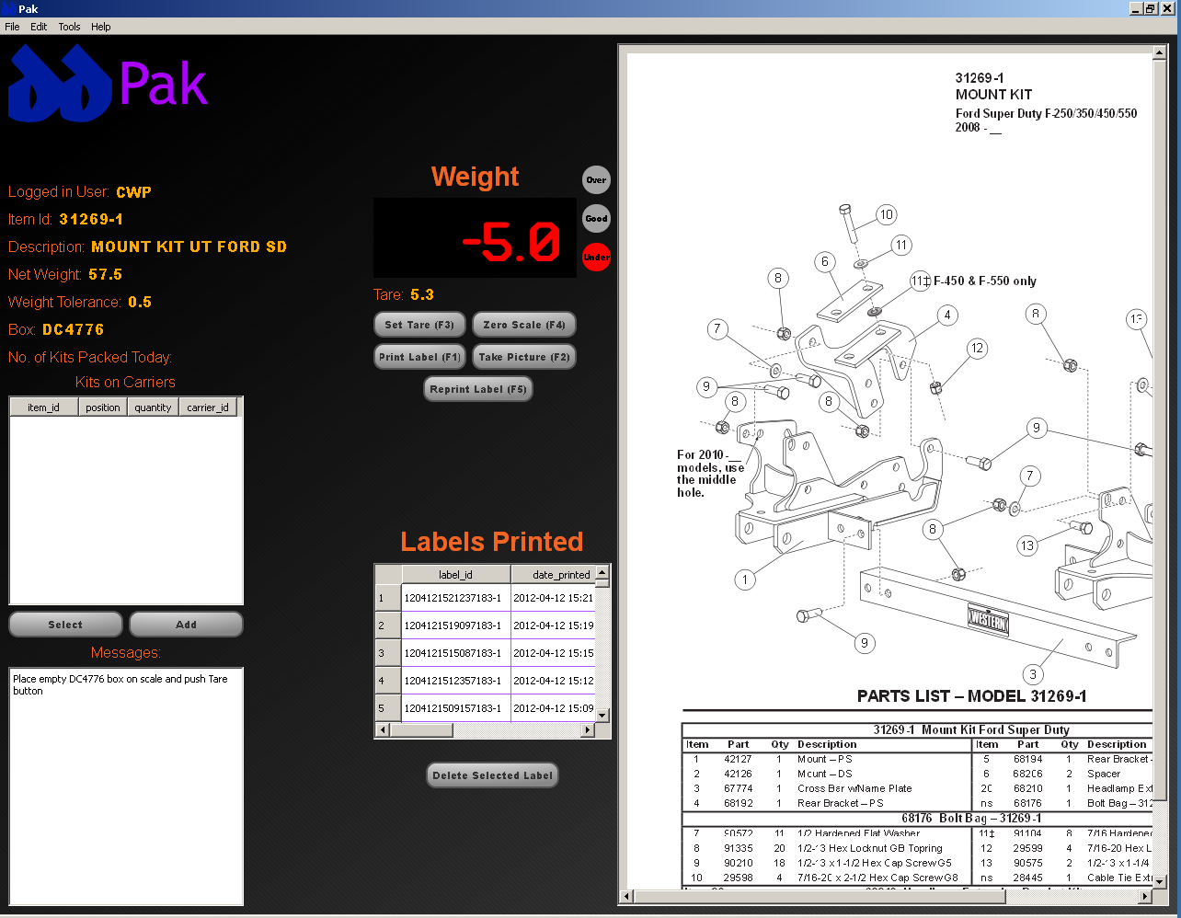

Find the box specified in the message area and place it on scale and push 'Tare' button. The weight display should now read 0. Place contents of the kit into the box according to the Packing SOW. Once all pieces are packed in the box, the green 'Good' indicator should be lit. If either of the red 'Over' or 'Under' indicators are lit, check the contents of the box. If the contents are OK, contact your DA or supervisor to find out the cause of the weight discrepancy. If the green indicator is lit then click the 'Print Label' button ( a label will not print unless the green indicator is lit). The printer will now generate three labels as shown below.
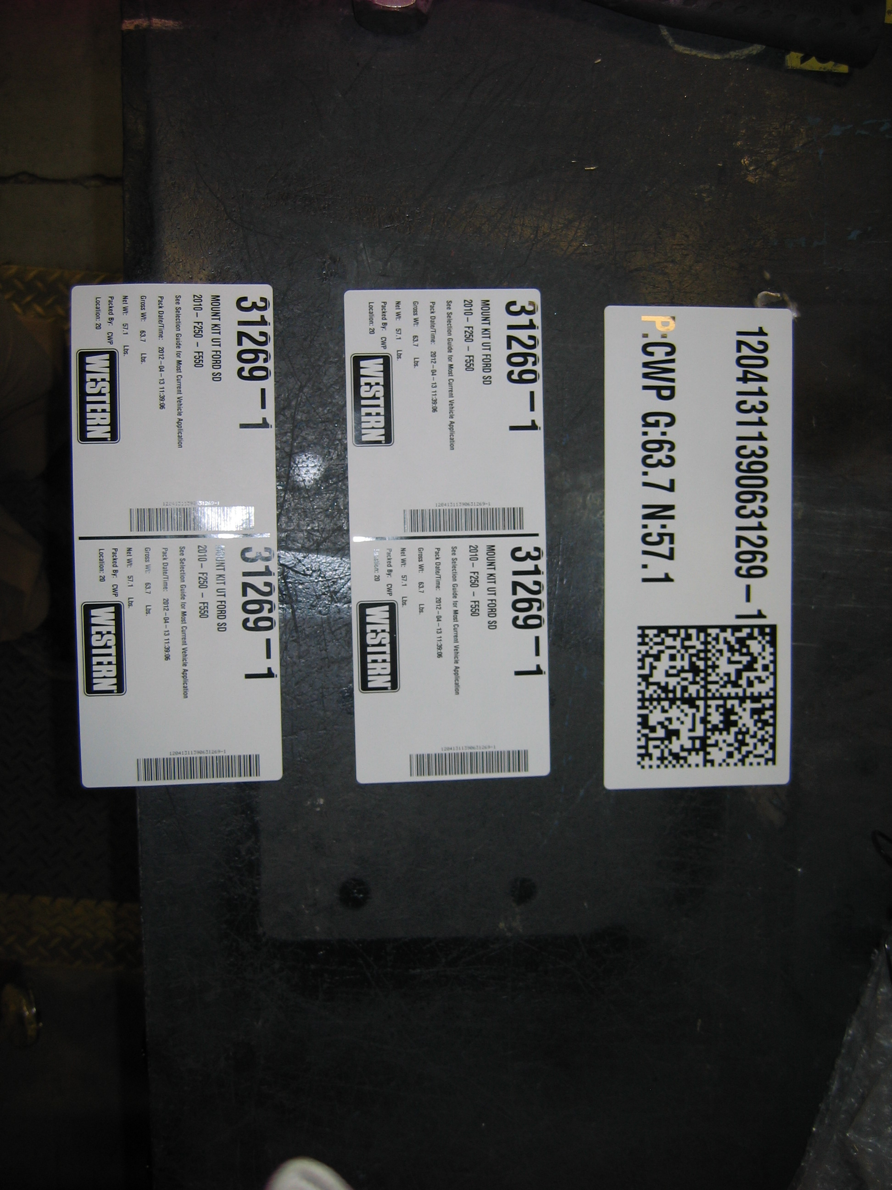

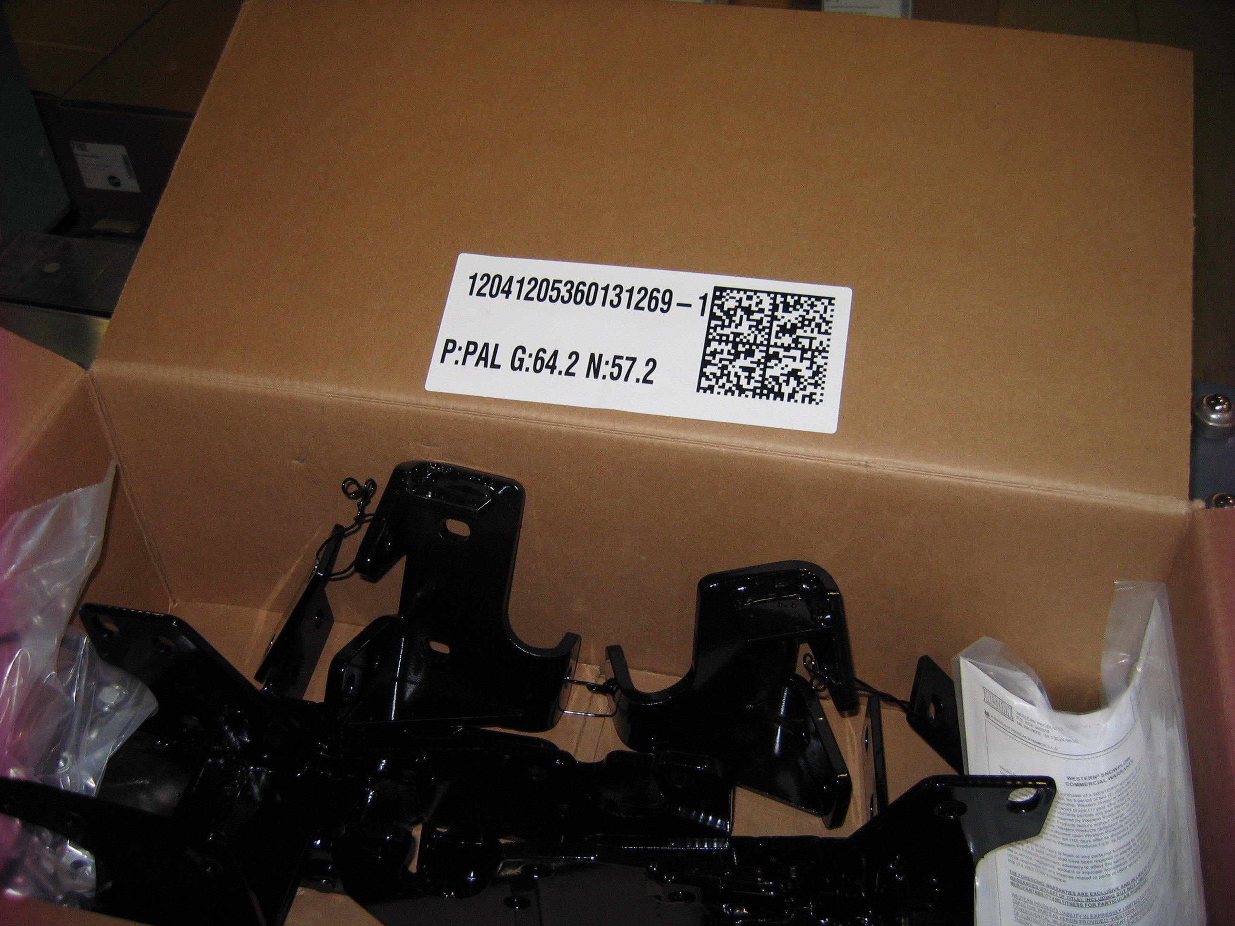
Affix the first label inside the box on one of the long flaps, place the other two labels on opposing corners of the box as shown in the following photos.

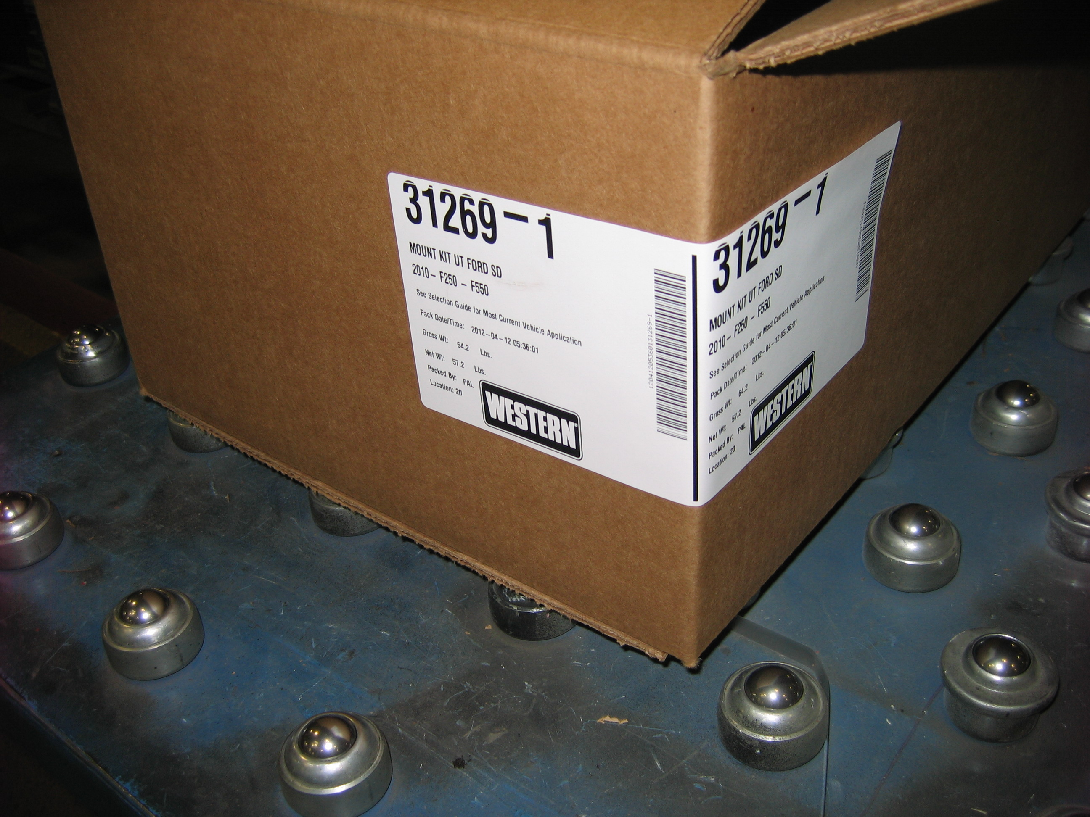

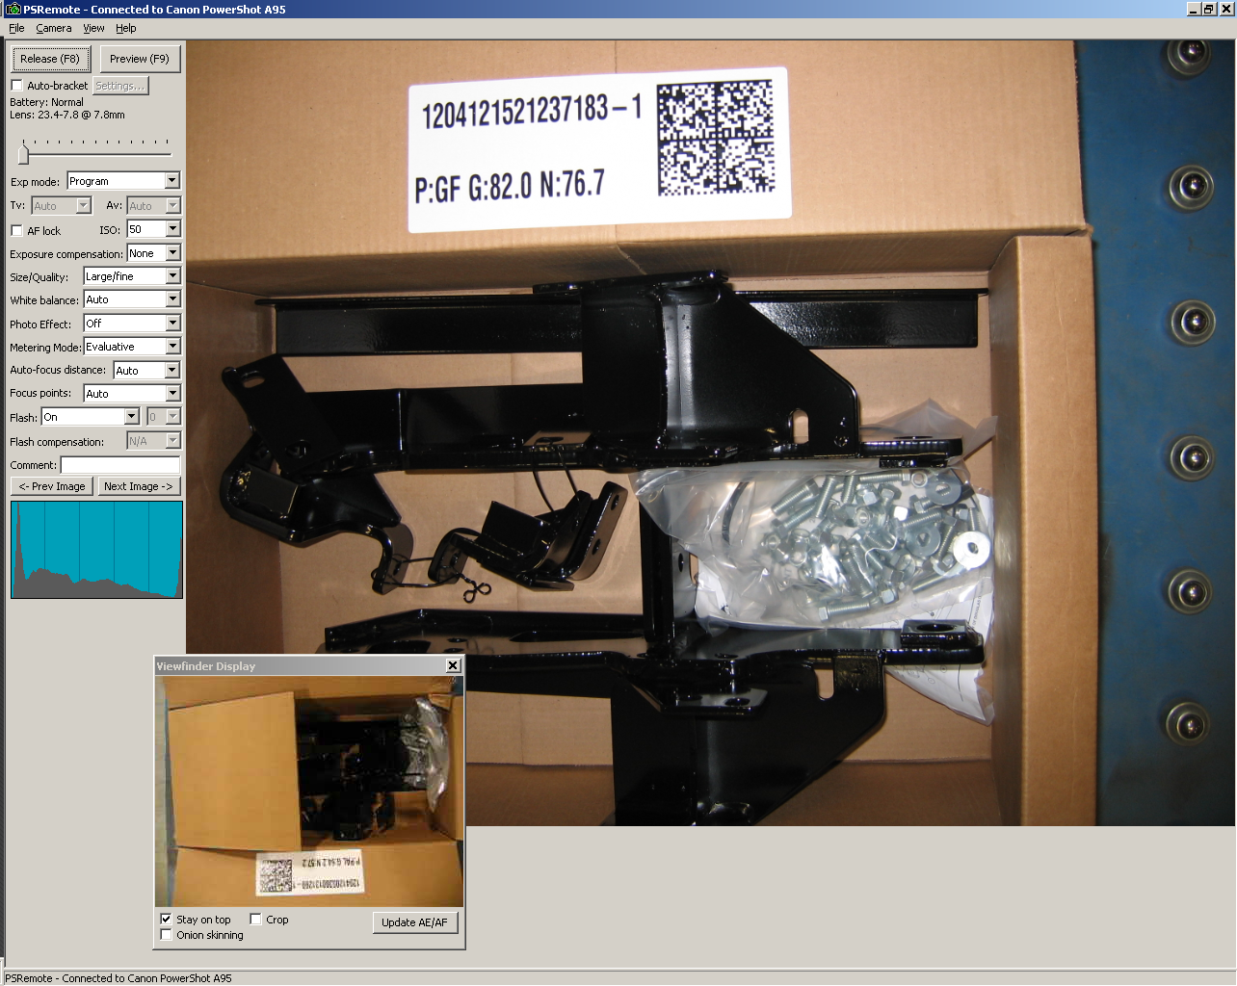
Take a picture of the kit next by clicking the 'Take Picture' button. It will take several seconds for the picture to download from the camera. Prior to taking the picture, make sure that all box contents and inside label will be visible by looking at the live viewfinder display in the PSRemote software window, as shown below.

Complete packing of the kit by strapping it.

It is important to keep an eye on the message area in the lower left side of the screen when things aren't working as expected. This will warn of situations such as trying to print two labels in a row without taking a picture or taking two pictures in a row. There are two special conditions involving labels. If the label gets ruined and packed box never leaves the scale, then you can click the 'Reprint Label' button and the printer will print a new set of labels with the same serial number on it. If the label gets ruined and box has left the scale then select the serial number of the ruined label from the Labels Printed view on the main screen and then click the 'Delete Selected Label' button. Then put the open box on scale and print a new label with a new serial number on it. If you need to take another picture of a kit because the one taken was not satisfactory, click the 'Release' button in the PSRemote main screen.

If at any time you want to see a report of what kits have been packed during a given day, select the Production Reporting option from the Tools menu and select the current date from the calendar and click the 'Generate Report' button. This will print out a summary of all kits packed and also identify labels with no picture and vise versa.
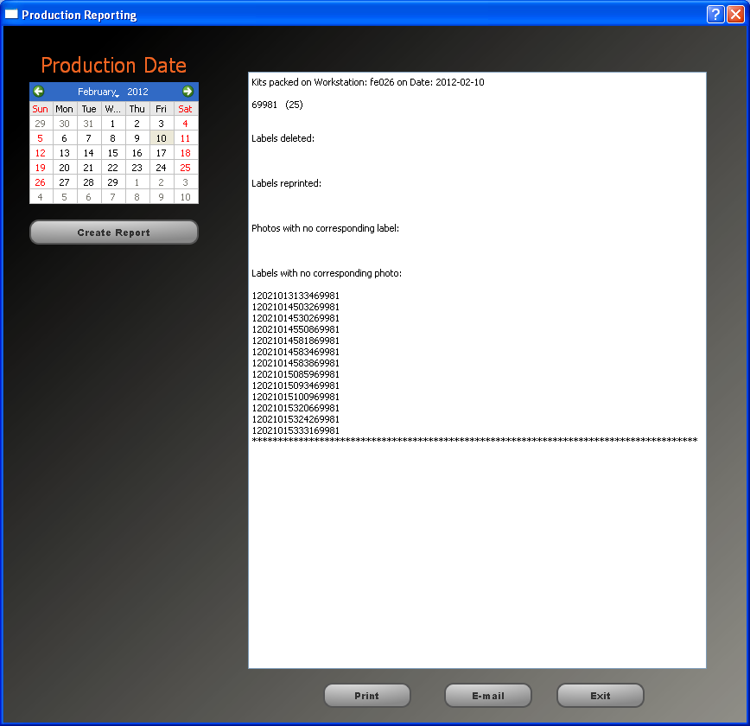

Administrative Functions

If a user is logged in that has administrative rights then there are extra functions available in ddPak. They include adding and modifying kits, users and application settings.

Menu Function: Edit » Kit Table

In this screen you may add a new mount kit to the software or modify an existing one. It is important that after modifying a field or adding a row that you hit “Enter” in order to commit the changes to the database.
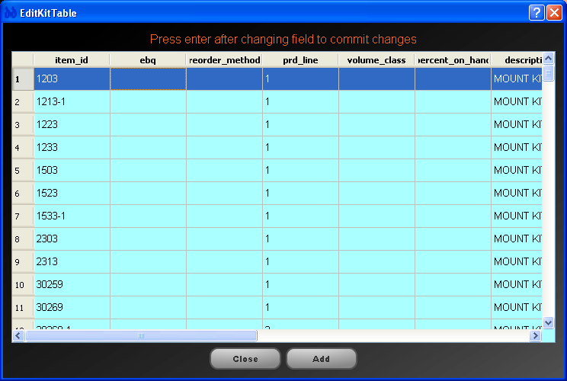
Menu Function: Edit » Users

This screen allows you to add new operators or modifying existing ones. It is also important in this screen to hit “Enter” after modifying a field in order to commit the changes to the database. There are only two types of role available, either “admin” or “user”. The difference being the ability to use any functions in the edit menu.

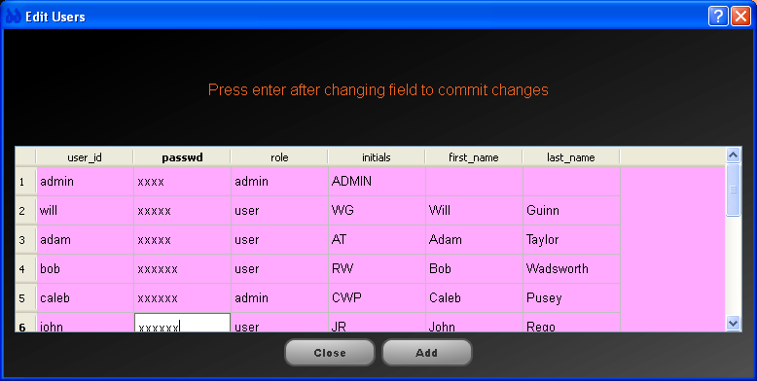
Menu Function: Edit » Preferences

In this screen you can alter hardware and software settings. On the “Serial Settings” tab you change the serial settings for the printer and scale. It is normally not necessary to change these after the scale and printer have been set up. If either of these devices are not working correctly the cables should be checked first. The drop down box for serial port will only show currently available serial ports on the system. If there are not enough serial ports available, Windows system settings should be checked.
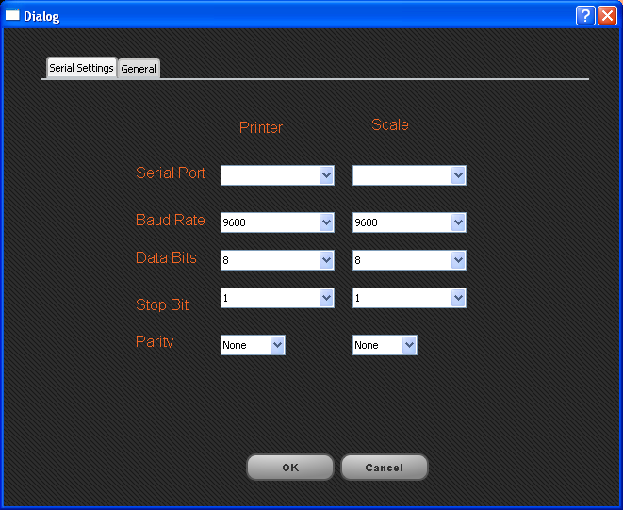
The general settings tab allows you to change some general settings affecting the operation of the software.
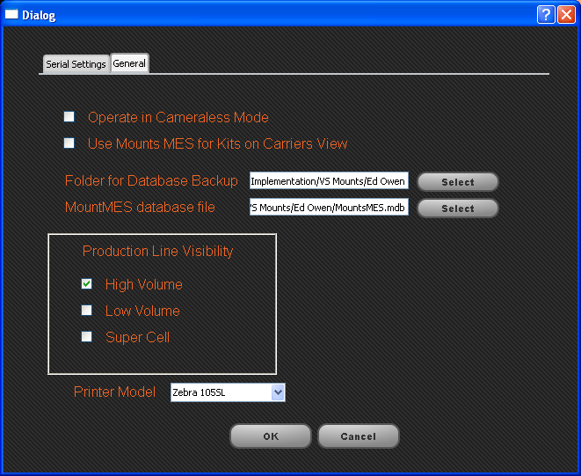

Operate in Cameraless Mode:

If for some reason the PSRemote software or the camera is not functioning correctly, this option will shutoff ddPak's requirement that a photo be taken after each label is printed. This should be considered an emergency short term fix in order to continue packing.

Use Mounts MES for Kits on Carrier View: (this feature isn't ready yet)

This allows ddPak to interface with the MountsMES production tracking system to fill in the Kits on Carriers box on the main operator screen. Otherwise kits have to be added manually with the “Add” button.

Folder for database backup:

Every time ddPak software starts up, it backs up it's internal SQLite database. This field determines the folder that it is backed up to. The folder must exist prior to the backup.

MountsMES database file: (not ready yet)

This tells ddPak where to look for the MountsMES database file. Currently the file selector only shows .mdb files in the selected directory.

Production Line Visibility:

These check boxes affect the kits on carriers view on the main operator screen. When adding a kit you will only see kits from the production lines selected. If using MountsMES for the kits on carriers view you will only see kits for the selected production lines.

Printer Model: (not ready yet)

In the event that the printer stops working this allows you to select a different printer model in order to keep on packing.

